

Faculty of Information Communication Technology

ITCS222 –Computer Organization and Architecture
Term Project: Assembly Programming

Presented by:

6388003 Phuriwat Angkoondittaphong

Submitted to:

Assoc. Prof. Dr. Chomtip Pornpanomchai
Dr. Ittion Rassameeroj

Semester 1 Academic year 2021
Contents
C code 3
C output 5
NASM code 6
NASM output 10

C code
// gcc app.c -o app && ./app
#include <stdio.h>
#define len 3

int find_min_index(int arr[], int start, int end){
int i;
int current_min = start;
for(i = start+1; i < end; i++){
if(arr[i] < arr[current_min]){
current_min = i;
}
}
return current_min;
}

void sort_array(int arr[], int start, int end){
int i, j, t;
for(i = start; i < end; i++){
j = find_min_index(arr, i, end);
t = arr[j];
arr[j] = arr[i];
arr[i] = t;
}
}

void print_array(int arr[], int start, int end){
for(int i = start; i < end; i++){
printf("%d ", arr[i]);
}
printf("\n");
}

int main(){

int a[len];
int i;
printf("input 3 numbers: ");
for(i = 0; i < len; i++){
scanf("%d", &a[i]);
}
printf("before sort: ");
print_array(a, 0, len);
sort_array(a, 0, len);
printf("after sort : ");
print_array(a, 0, len);
return 0;
}

C output
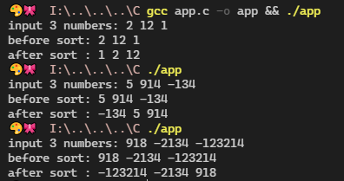
If you want to run this, try executing app.exe in C folder (windows only).
Built it on your own OS using `gcc app.c -o app`

NASM code
; ./nasm -f obj -d obj_type .\app.asm && ./bcc32 .\app.obj .\driver.obj .\asm_io.obj && ./app

%include "asm_io.inc"

segment _DATA public align=4 class=DATA use32
INPUT_TEXT db 'input 3 numbers: ', 0
BEFORE_TEXT db 'before sort: ', 0
AFTER_TEXT db 'after sort : ', 0
SPACE db ' ', 0

INT_SIZE equ 4 ; size of integer's author using below

segment _BSS public align=4 class=BSS use32
endarr resd 1 ; end of the array that author want it to be (default is 3)
i resd 1 ; typical loop variable
j resd 1 ; typical loop variable
min_i resd 1 ; max index, will use in find max
num resd 3 ; array
t resd 1 ; tempory for swapping operation

group DGROUP _BSS _DATA

segment _TEXT public align=1 class=CODE use32
global _asm_main
_asm_main:
enter 0,0 ; setup routine
pusha

mov dword [endarr], 3
mov dword [i], 0

mov eax, INPUT_TEXT
call print_string
while_input:

; read from stdin
mov ecx, [i]
call read_int
mov [num + ecx * INT_SIZE], eax ; sizeof(dtype) = 4

mov ecx, [i]
inc ecx
mov [i], ecx
mov ebx, [endarr]
cmp ebx, ecx
jg while_input ;end of while_input

mov eax, BEFORE_TEXT
call print_string
; init for outputing array
; set i = 0
mov dword [i], 0
while_output1:
; calculate for num[i] = num + sizeof(dtype) * i
mov ecx, [i]
mov eax, [num + ecx * INT_SIZE] ; sizeof(dtype) = 4
call print_int
mov eax, SPACE
call print_string

; loop condition
inc ecx
mov [i], ecx
mov ebx, [endarr]
cmp ecx, ebx ; if i < endarr: goes up
jl while_output1
; end of while_output1

call print_nl

; find max and replace here
mov eax, 0
mov [i], eax
selection_sort:
mov eax, [i]
mov ebx, [endarr]
cmp eax, ebx
jge end_sort

; init for loop_find_min
mov ecx, [i]
mov [min_i], ecx
inc ecx
mov [j], ecx
loop_find_min:
mov eax, [endarr]
mov ecx, [j]
cmp ecx, eax
jge end_loop_find_min ; if j < endarr: do below, else: jmp to the end

mov ecx, [min_i]
mov ebx, [num + ecx * INT_SIZE] ; get current small value
mov ecx, [j]
mov eax, [num + ecx * INT_SIZE] ; get `this` value
cmp eax, ebx
jge if_not_new_min ; if num[j] < num[min_i]: do below, else: skip below

; if_new_max
mov [min_i], ecx ; min_i <- i ; set a new small

if_not_new_min: ; and after set new max
; mov ecx, [j]
inc ecx ; assumn ecx = j
mov [j], ecx ; j++
jmp loop_find_min
; ends loop_find_min here

end_loop_find_min:

; swap num[i] <=> num[min_i]
mov ecx, [i]
mov eax, [num + ecx * INT_SIZE]
mov ecx, [min_i]
mov ebx, [num + ecx * INT_SIZE]

mov [num + ecx * INT_SIZE], eax ; at write at num[min_i] <- num[i]
mov ecx, [i]
mov [num + ecx * INT_SIZE], ebx ; at write at num[i] <- (old) num[min_i]

; i++
inc ecx
mov [i], ecx
jmp selection_sort

end_sort:

mov eax, AFTER_TEXT
call print_string
; init for outputing array
; set i = 0
mov dword [i], 0
while_output2:
mov ecx, [i]
mov eax, [num + ecx * INT_SIZE] ; calculate for num[i] = num + sizeof(dtype) * i
call print_int
mov eax, SPACE
call print_string

; loop condition
inc ecx
mov [i], ecx
mov ebx, [endarr]
cmp ecx, ebx ; i < endarr
jl while_output2 ; end of while_output2

popa
mov eax, 0
leave
ret ; return 0

NASM output
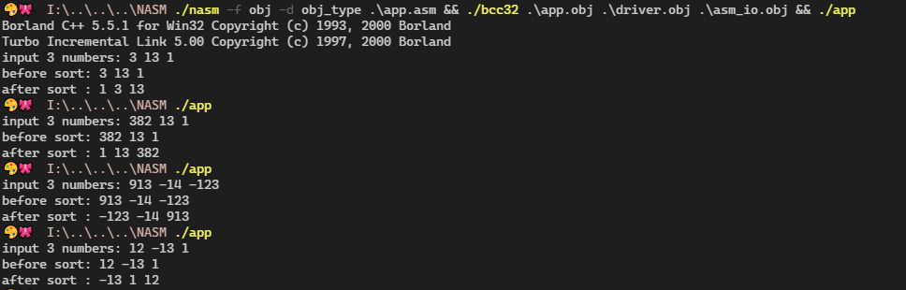

If you want to run this, try executing app.exe in NASM folder.
Built it on your own using `./nasm -f obj -d obj_type ./app.asm && ./bcc32 ./app.obj ./driver.obj ./asm_io.obj `
(windows only)

